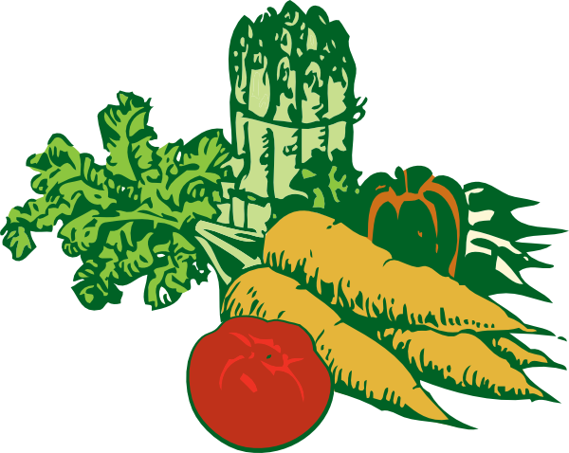
GrowingGreat Fruits & Vegetables Word Search

Search in the puzzle for the fruits and veggies from the list below. Once you find the word, cross it out on the list. If you have tried that fruit or veggie, put a star next to it and say what it tasted like.

B U V Q B E C R C G X G P S Z
J R A Z E S A R I O U A T C P
I C U A E Z U F A A C U G E M
T O E S T Y L G V D O O N I P
I L M A S X I A A R I D N O X
U L A R F E F L P R I S M U E
R A M K U H L S E V A E H E T
F R A O B I O S E N G P H Z H
R D C Y A M W O S R N C S G T
A M I V S B E W A P Y E A A K
T N J E M A R N S L R E F W X
S N E E R G A N G J C O L E V
D R Z D E T P A P A Y A U A W
Y R K R E K O H C I T R A T K
A P R I C O T O G N A M A F S

APRICOT
ARTICHOKE
ASPARAGUS
BEETS
BRUSSELS SPROUTS
CAULIFLOWER
COCONUT
COLLARD
ENDIVE
FENNEL
FIG
GREENS
GUAVA
JICAMA
KALE
LYCHEE
MANGO
OKRA
PAPAYA
POMEGRANATE
RADISH
SPROUTS
STARFRUIT
YAM

