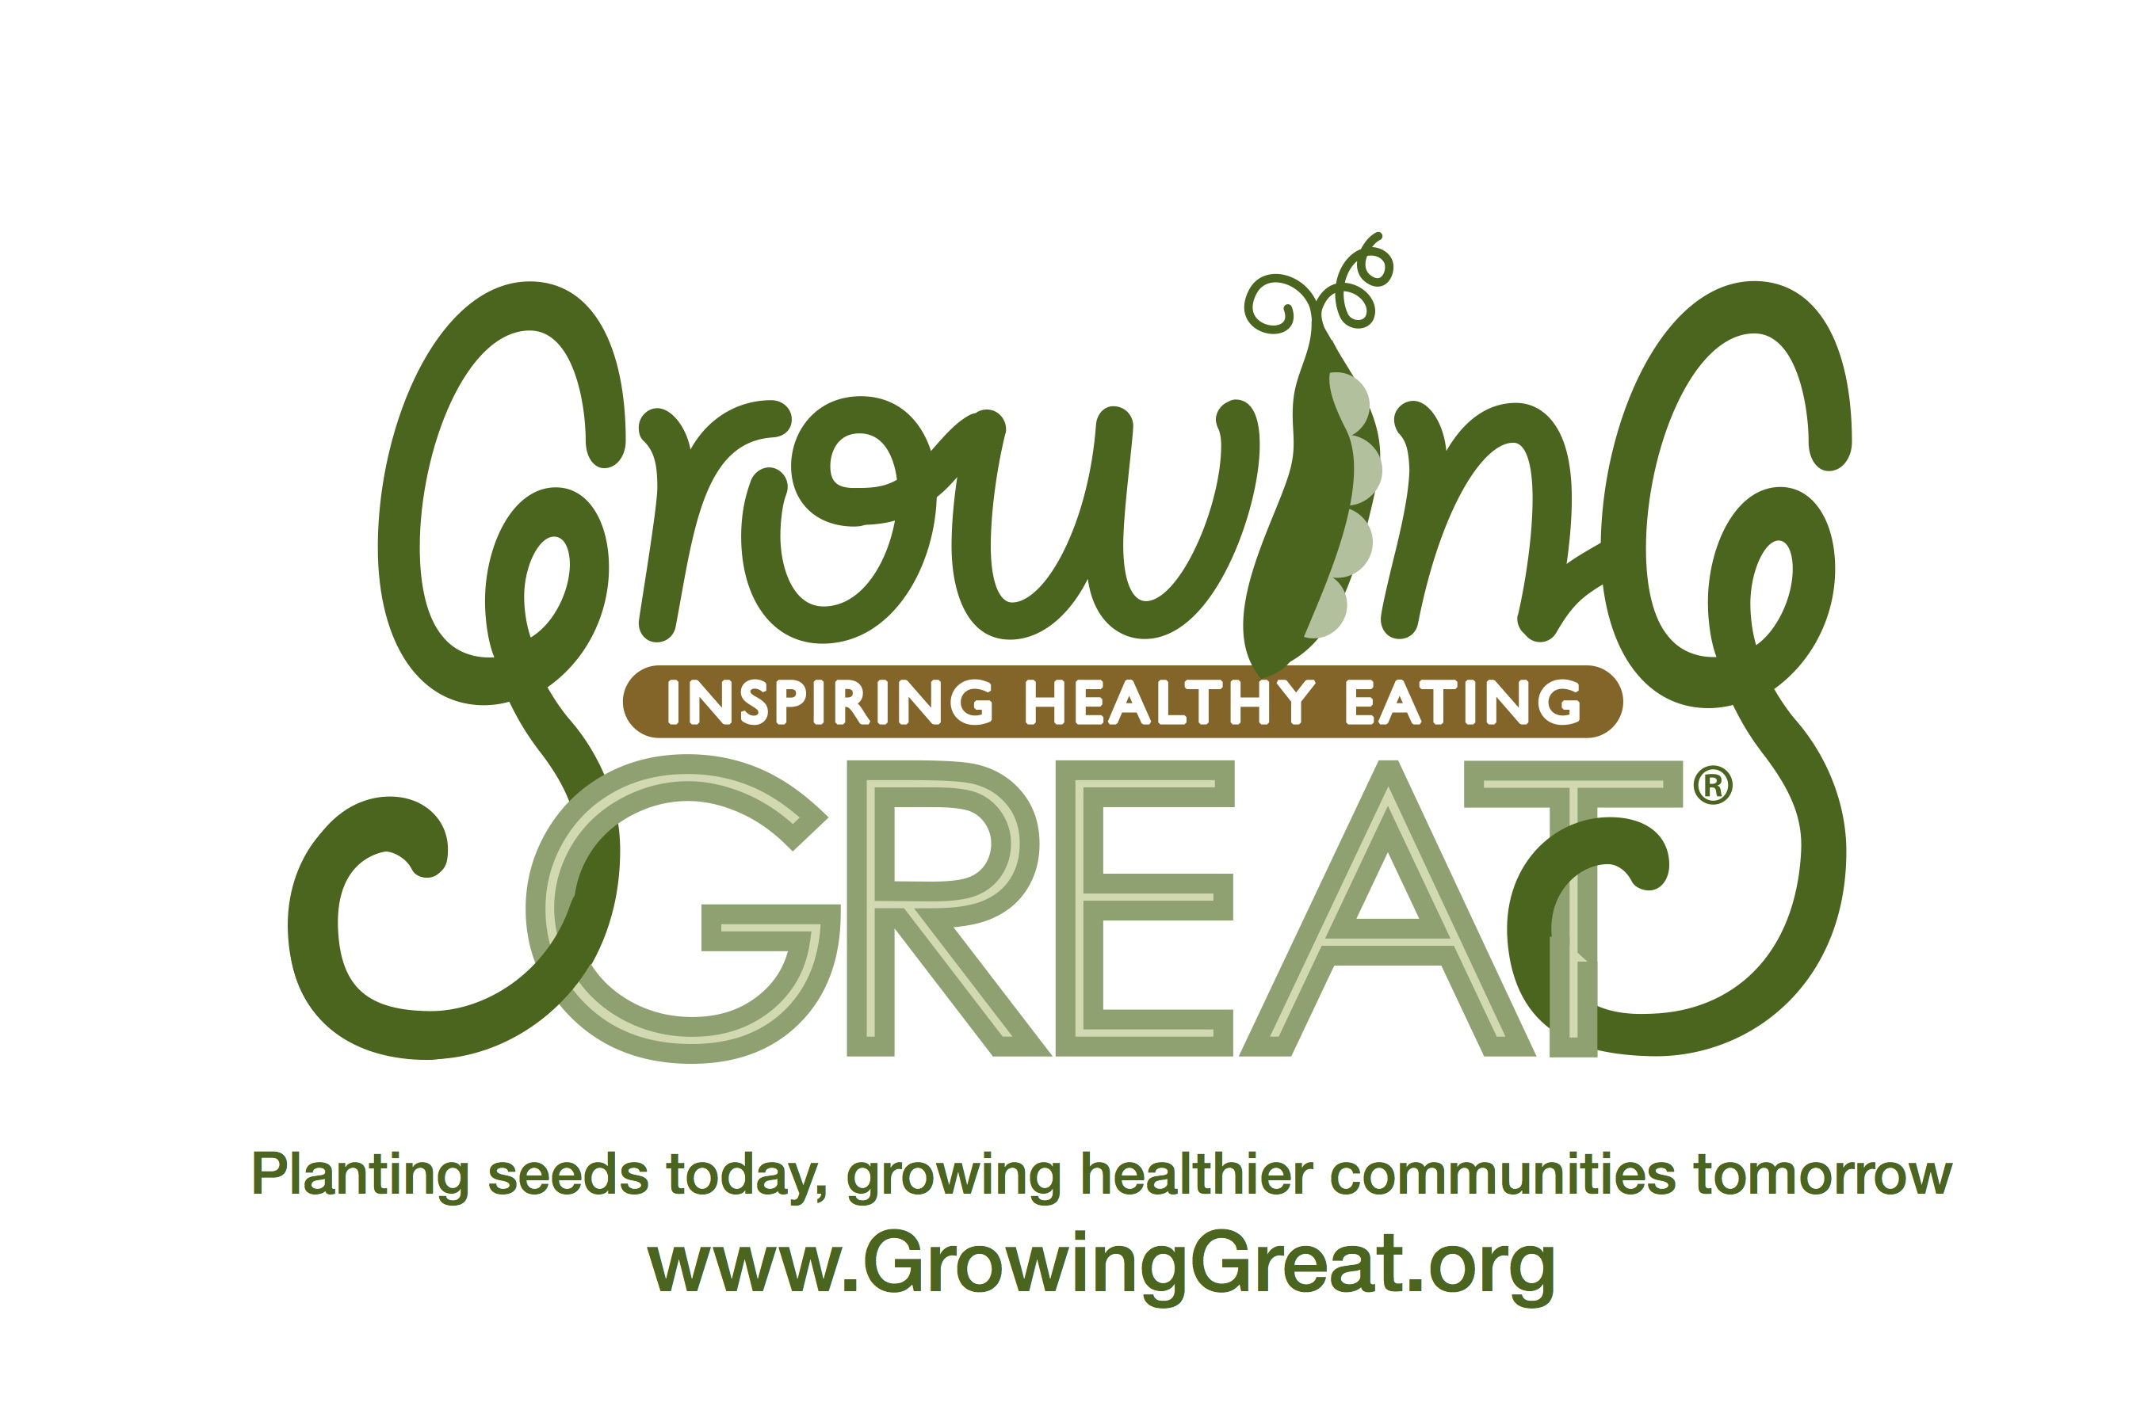

Dear Teacher:

GrowingGreat Pilot K-2nd Lesson #2 – Farm to Table

Today’s lesson is “Farm to Table.” Your GrowingGreat Docent will lead the students through an interactive lesson designed to teach them that foods are grown on a farm, by a farmer, before it gets to a grocery store, farmers’ market or restaurant. A GrowingGreat “Grill Me About” handout is available to be sent home via email or backpack. Please contact your GrowingGreat Docent for an electronic document.

Your Teacher Packet includes:

- An outline of the lesson

Suggested books to compliment the “Farm to Table” lesson:
How Did That Get In My Lunchbox? The Story of Food by Chris Butterworth

We hope you and your students enjoy the lesson!

Sincerely,

GrowingGreat

LESSON OUTLINE
K-2 Pilot Lesson # 2: Farm to Table

Objective: Students understand that a farmer grows food on a farm before it gets to a grocery store, farmer’s market or restaurant.

Main Concepts
- Humans eat food to live and grow.
- Our food originates from a farm.
- Whole and close to the source foods are high-quality options.
- We buy food from grocery stores, farmers’ markets, schools, and restaurants.
- A farmer has to grow fruits, vegetables, and grains before we can buy them.

Lesson Outline (approximately 45 minutes)
- Read Book: (10 minutes)
- K-1st Grade: The Little Red Hen by Byron Barton
- 2nd Grade: Bread Comes to Life: A Garden of Wheat and a Loaf to Eat by George Levenson

- Introduction/Review: (10 minutes)
- Review GrowingGreat Nutrition Lesson #1.
- Living things like plants and animals need food to live and grow.
- Humans need a variety of foods from different food groups.
- Half your plate at every meal should be made up of fruits and vegetables.

- Lesson: (10-15 minutes)
- Main Concepts – a farmer grows foods we eat such as fruits, vegetables, and grains beginning with planting a seed in the ground. Seeds need water and sun to grow into a plant or tree.

- Activity: (10 minutes)
- Butter in a jar

- Review/Conclusion: (5 minutes)

Note: GrowingGreat curriculum aligns with Common Core Standards and Next Generation Science Standards. Please refer to lesson document for standards.

