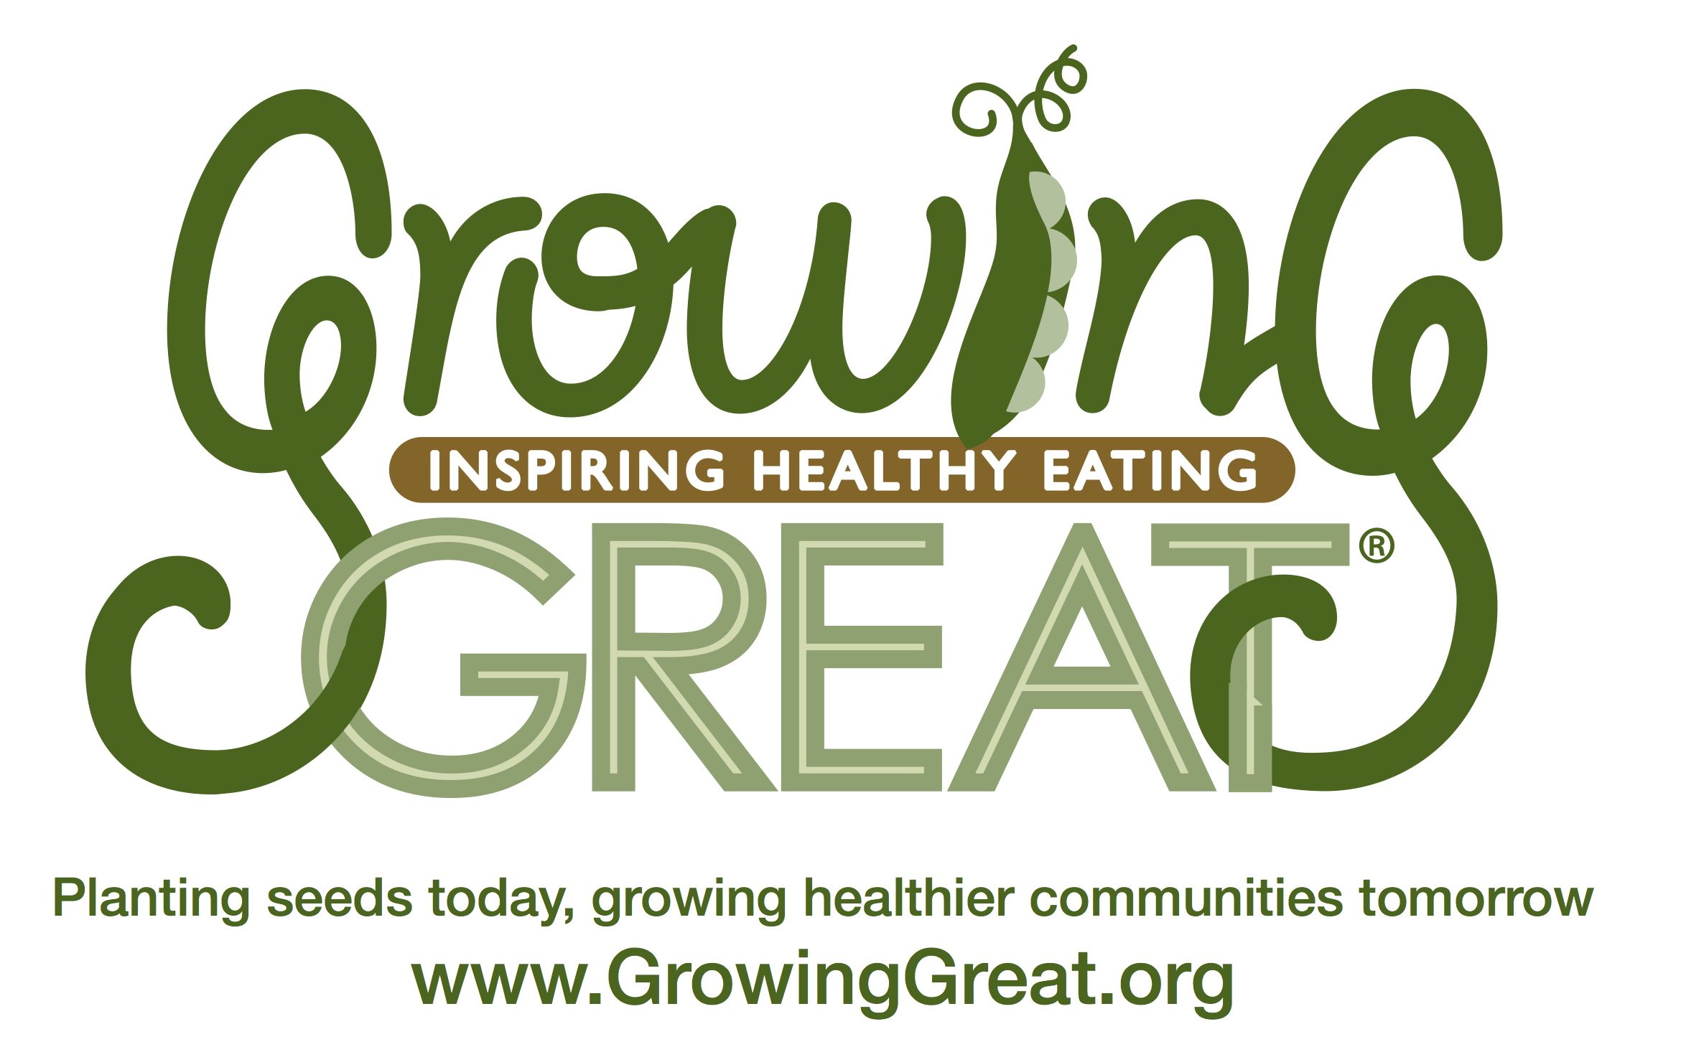
Grill Me About…
Farm to Table
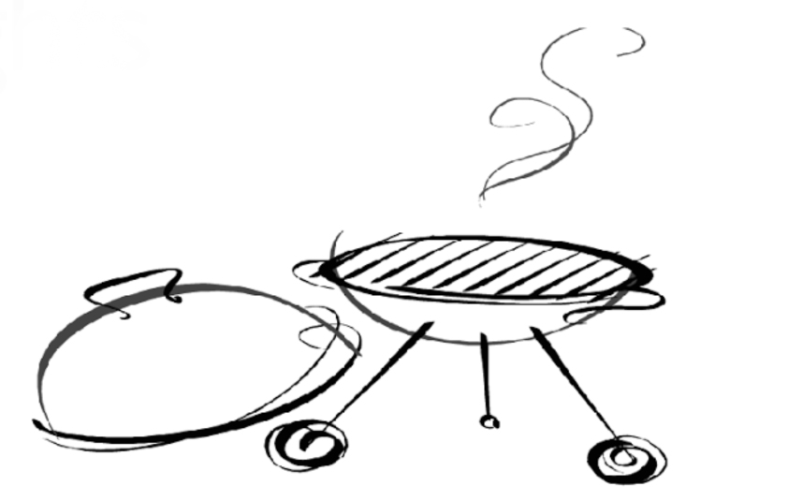
Ask me what I learned about farmers and their farms in my GrowingGreat classroom nutrition lesson:

- Where does our food grow?

- What can we do with the wheat that a farmer grows?

- What are the 5 things you need to grow healthy apple trees?
Homemade Butter in a Jar

1 Mason jar with lid
1 Carton whipping cream

Directions:
Pour half a carton of whipping cream into a mason jar. Seal it tight with the lid. Start shaking the jar up and down in a fast motion. After approximately 10 minutes there will be a “thump” sound. This tells you that the butter and buttermilk are separating. Open the jar and pour out any remaining liquid. The solid form is butter! *Add any herbs from the garden to the butter for a creative flavor, or just use “as is.” Serve with whole grain bread or crackers.

…………………………………
Answers:
- Our food starts growing on a farm.

- We grind wheat into flour to make breads and crackers.

- An apple tree needs a farmer, soil, seed, water and sun.

Hands-On Science Corner: Homemade Butter in a Jar
- Making butter in a jar is an example of liquids and solids that are consumed.
- Butter is a dairy product that is made directly from whole milk of an animal.
- When making the butter, observe the difference between a liquid and a solid.
- Use your senses to see, feel, taste and listen to the physical changes during the process of butter making.

Visit the Resources section at www.GrowingGreat.org for more hands-on science activities.

K-2 Classroom Nutrition
Pilot Program: Lesson #2
Farm to Table

Where do our foods come from? All foods such as fruits, vegetables, grains, and dairy, come from farms.

If I were . . .
If I were an apple farmer I would be growing apples. I would plant a seed in the soil, and water the seed. The sun would provide light or energy to help the seed grow into a healthy apple tree. I would harvest the apples and get them ready to sell on the farm or transport to a grocery store, farmers’ market or restaurant.

From Wheat to Bread: Wheat farmers grow wheat grains. These grains are milled into wheat flour. Wheat flour is whole, “close to the source,” and minimally processed. Wheat flour is a main ingredient in whole grain breads, crackers, and cereals.
GrowingGreat’s Philosophy

GrowingGreat’s mission is to empower every child to grow up healthy through science-based garden and nutrition education.

GrowingGreat advocates:
- eating a wide variety of colorful, whole foods that are close to their original source
- choosing higher-quality, beneficial foods more often
- appreciating the impact food has on our overall well-being so that we can think, feel, and perform at our best all day long

Which is closest to the source or to nature?
- Whole Wheat Bread
- Wheat Grain
- Wheat Flour

Answer: Wheat Grain

Optional Reading:
The Little Red Hen by Bryon Barton
From Wheat to Bread by Kristin Thoannes Keller
The Apple Pie that Papa Baked by Lauren Thompson
Milk from Cow to Carton by Aliki
Bread Comes to Life: A Garden of Wheat and a Loaf to Eat by George Levenson
How Did That Get in My Lunch Box? The Story of Food by Chris Butterworth

