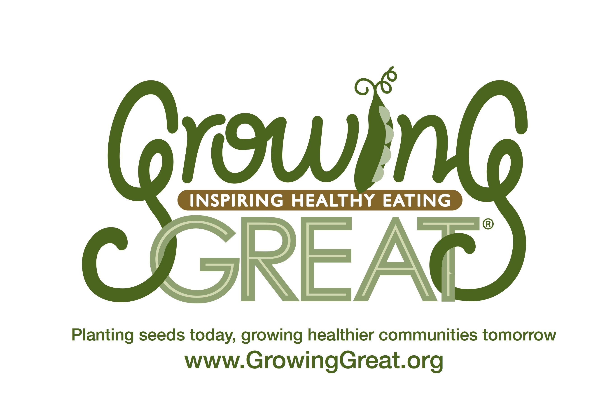
Supply Checklist
K-2 Pilot Lesson #2
Farm to Table

Supplies provided by GrowingGreat Pilot Program

Book for Lesson

- K-1st Grades: The Little Red Hen
- 2nd Grade: Bread Comes to Life: A Garden of Wheat and a Loaf to Eat

Role Play Demonstration (growing an apple tree)

- Farmer: Gloves/shovel
- Soil: Bag of potting soil
- Seed: Apple seed packet
- Water: Watering can
- Sun: Yellow ball
- Whole Apple: Plastic apple

Wheat Demonstration
- Wheat stalk
- Whole wheat flour
- Whole wheat loaf of bread

Activity: Butter in a jar

- Mason jar with lid per classroom
- (1) Carton whipping cream per (2) classrooms

*DOCENT NOTES: Suggested to have all supplies set and ready before lesson.

