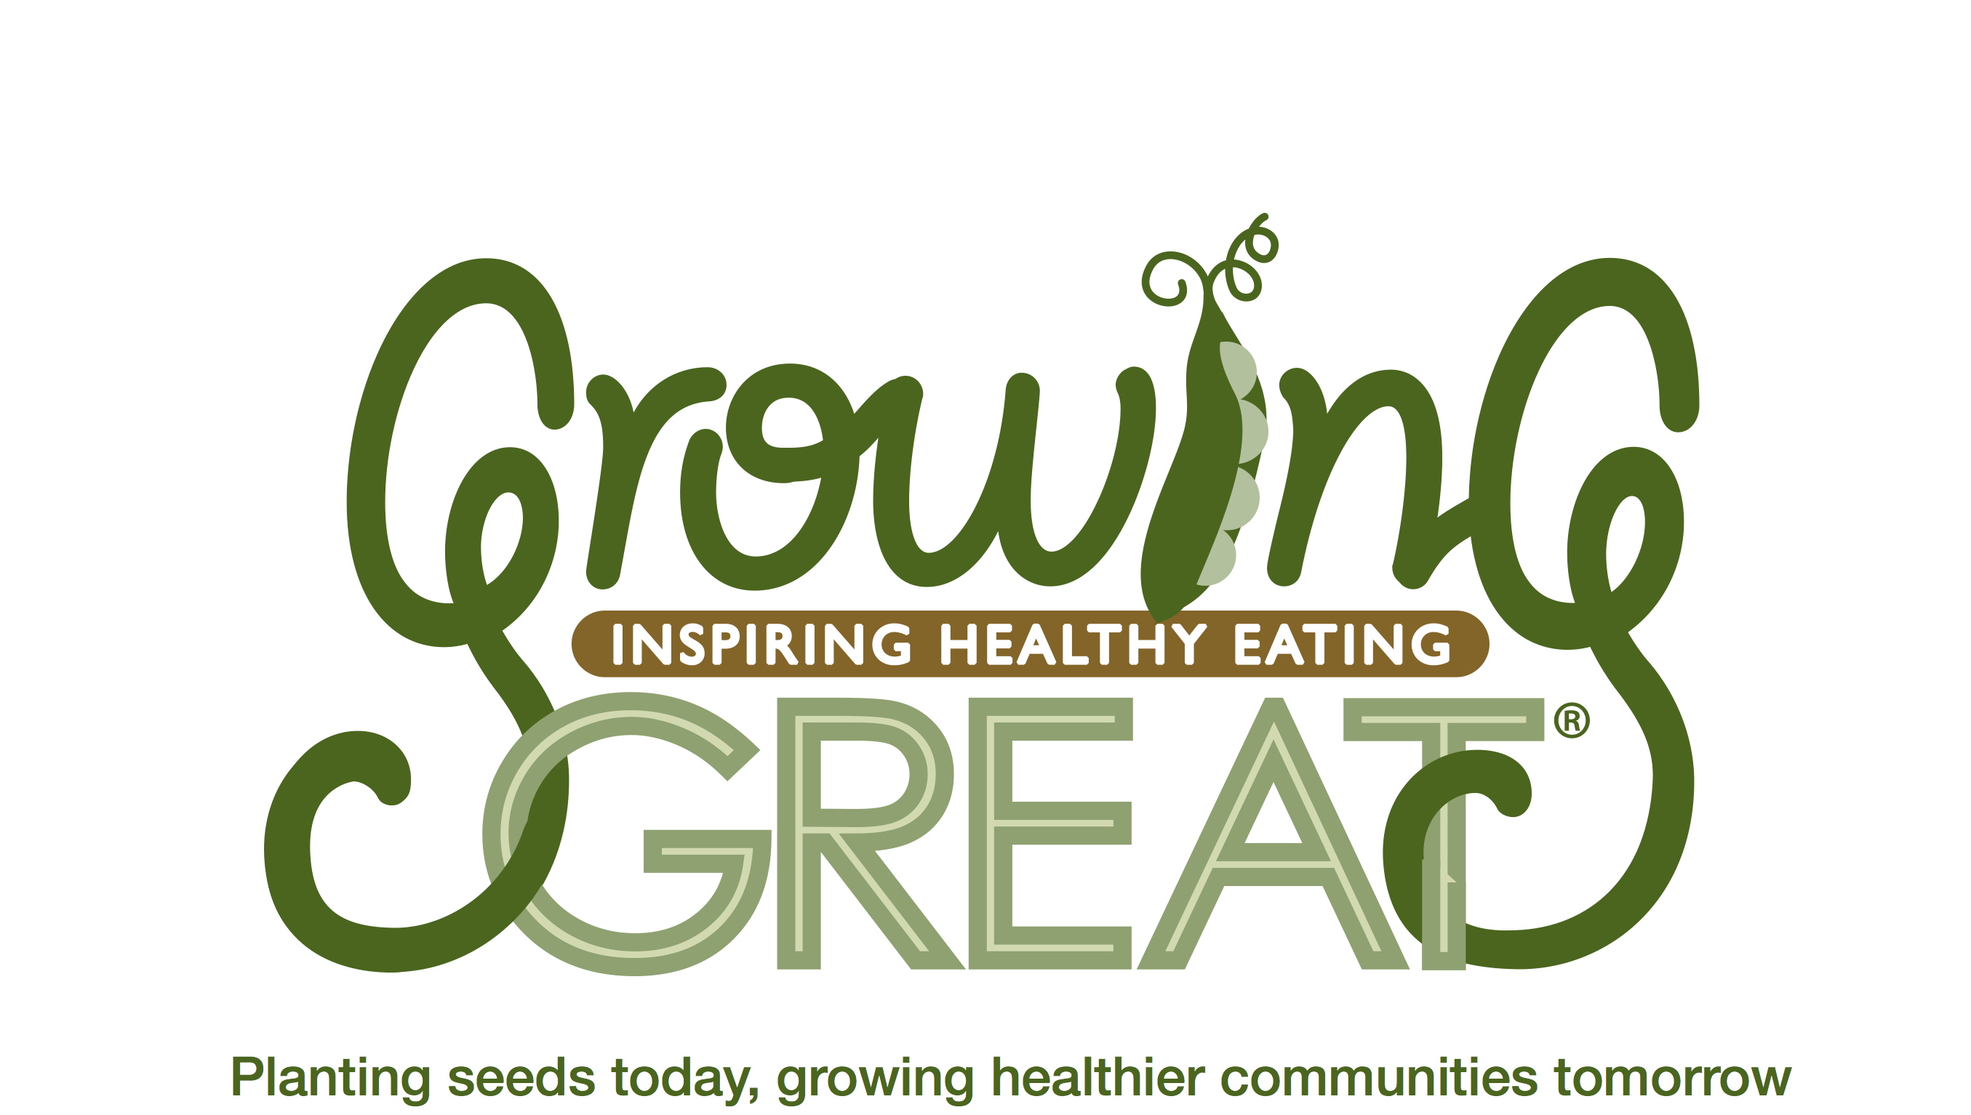
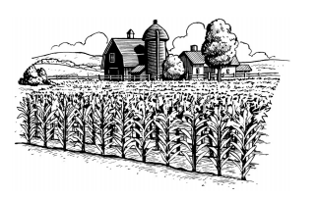

Farm To Table:
Volume 1, Lesson 2 in GrowingGreat’s Science-Based Nutrition Education Program for Grades K-2
By Jill Coons

OBJECTIVE: Students learn that food is grown on a farm, by a farmer, before it gets to a grocery store, farmers’ market or restaurant.

MAIN CONCEPTS:
- Humans eat food to live and grow.
- Our food originates from a farm.
- Whole, close to the source, minimally-processed foods are best.
- We buy food from a grocery store, farmers’ market, school, or restaurant.
- A farmer has to grow foods, grains, and milk before we can eat them.

STANDARDS RESOURCES:
Common Core Standards
Language Arts
K.W.3: Use a combination of drawing, dictating and writing to narrate a single event or several loosely-linked events. Tell about the events in the order in which they occurred, and provide a reaction to what happened.

1.L.5.c: Identify real-life connections between words and their use.

2.SL.3: Asks and answers questions about what a speaker says in order to clarify comprehension, gather additional information, or deepen understanding of a topic or issue.

Next Generation Science Standards
Life Science
K-LS1.C: All animals need food in order to live and grow. They obtain their food from plants or from other animals. Plants need water and light to live and grow.
1-LS1-1: Use materials to design a solution to a human problem by mimicking how plants and/pr animals use their external parts to help them survive, grow, and meet their needs.
2-LS2-1: Plan and conduct an investigation to determine if plants need sunlight and water to grow.
2-LS4-1: Make observations of plants and animals to compare the diversity of life in different habitats.

LESSON OUTLINE

1. Read Book (10 minutes)
K -1st Grade: The Little Red Hen from a Little Golden Book/Random House, Inc.
2nd Grade: Bread Comes to Life: A Garden of Wheat and a Loaf to Eat by George Levenson

2.Introduction/Review: (10 minutes)
- Review Lesson #1
- Living things (such as plants and animals) need food and water to live and grow.
- Humans need a variety of foods from different food groups.
- Half your plate at every meal should be made up of fruits and vegetables.

3. Lesson: (10 minutes)
- Main concepts - A farmer grows foods we eat such as fruits, vegetables, dairy and grains, beginning with planting a seed in the ground. Seeds need water and sun to grow into a plant or tree.
4. Role Play Demonstration: (10 minutes)
- Student demonstration of how a farmer starts growing a food (apple tree)
5. “Butter In A Jar” Activity
- Students make homemade butter in a jar
6.Review/Conclusion: (5 minutes)
TOTAL APPROXIMATE TIME: (45 minutes)

*DOCENT NOTES: Most likely, students in K-1st will need to be sitting on a carpet and 2nd Grade will be at desks. Either situation is great. It is important to hold the attention of the students.

LESSON SCRIPT

DOCENT: In the first GrowingGreat lesson we talked about what livings things (like plants and animals, including humans) need to live and grow. We also discussed how humans need a variety of foods to stay healthy, make us strong, and help us grow.

DOCENT: Who can recall what animals need to live and grow? (pick 1-3 students)
- STUDENTS: “Food! Water! Sun!” (Docent guide students if they don’t have answer)
DOCENT: What about humans? Do we need food, water and sun?
- : STUDENTS: “Yes!”
DOCENT: Humans eat plants like bananas and carrots and eat animals like fish and chicken.
DOCENT: Do we eat shoes? (humor)
- STUDENTS: “NOOOOOOO!” That is silly.
DOCENT: Why don’t we eat shoes?
- STUDENTS: (Example: That would make us sick.)
DOCENT: Should humans only eat one kind of food throughout the day?
- STUDENTS: “No!”
DOCENT: Who remembers the 5 food groups that humans need to eat to live and grow healthy? (Docent calls on 5 students)
- STUDENTS: Fruits, Vegetables, Grains, Proteins and Dairy

*DOCENT NOTES: Ask students to give examples of each food group (example: apple, rice, fish, milk).

*DOCENT NOTES: Ask students if they “decorated” their plates with all the food groups at home.

DOCENT: Friends, we are now going to read a book together. After we read the book, I will tell you what we are going to be talking about in your GrowingGreat Lesson #2.

*DOCENT NOTES: K-1st Grades read The Little Red Hen. 2nd Grade read Bread Comes to Life: A Garden of Wheat and a Loaf to Eat

DOCENT: Thank you for being such great listeners while I read the book! Today we will be talking about how important a farmer is and what types of products the farmer offers us in our everyday life. There are fruit and vegetable farmers, milk farmers, chicken farmers, cotton farmers and wheat farmers. These are just a few types of farmers that represent the 5 food groups. Each of these foods starts on a farm before it goes to a store, restaurant or farmers’ market. Let’s begin with the fruit and vegetable farmer.

*DOCENT NOTES: Please feel free to reinforce the book themes throughout the lesson. For example, the Little Red Hen planted wheat from seed, harvested, and made flour. Bread Comes to Life: A Garden of Wheat and a Loaf to Eat discusses how wheat is picked by a farmer, milled into flour, and then whole wheat bread is made.

DOCENT: If I were an apple tree farmer, what fruit would I grow?
- STUDENTS: Apples
DOCENT: If I were an egg farmer, what type of animal would I be raising?
- STUDENTS: “Chickens or even Ducks!”
DOCENT: If I were a milk farmer, what type of animal would I be raising?
- STUDENTS: “Cows or Goats!”
DOCENT: Students? If I wanted to make my own butter would I go to an apple farm?
- STUDENTS: “Nooooo!”
DOCENT: A chicken farm?
- Students: “Noooooo!”
DOCENT: I would go to a cow farm! Did you know butter is made from milk? DOCENT: If I were a wheat farmer, I would grow wheat for what types of foods?
- STUDENTS: “Flour” (Docent direct students if needed)
DOCENT: Flour is found in cereals, breads, and crackers.

*DOCENT NOTES: Reference books: K-1st Grade: refer to The Little Red Hen and 2nd Grade: refer to Bread Comes to Life: A Garden of Wheat and a Loaf to Eat

DOCENT: Class, you are doing a wonderful job! All these foods that help us grow and make us strong start on a piece of land we call a farm. Who has been on a farm? (2-4 students answer) Today, we are going to have some fun together. I am going to need you to pay attention and follow my directions. We are going to talk about the journey an apple takes to get to the grocery store, farmers’ market or restaurant. Let us walk through a day in the life of an Apple Farmer!

DOCENT: If you were an apple farmer, what things would you need to grow an apple? Please raise your hands. (Call student with correct answer up to front of classroom and have students hold props – Farmer Gloves/Shovel, Soil, Apple Seed Packet, Watering Can, Yellow Ball)

- Farmer
- Soil
- Seed
- Water
- Sun
- Plastic Apple for Docent

- STUDENTS: Farmer, soil, apple seeds, water, and sun (Docent call on 5 students. Hand each student a prop -- farmer gloves/shovel, bag of soil, apple seed packet, watering can, and yellow ball (sun))

DOCENT: A farmer digs a hole in the ground, plants an apple seed, covers the seed with soil, and waters the seed. The sun gives the seed energy to grow. All plants need 3 things to grow - soil, water, and sun. Once the seed becomes a tree, it produces apples. A farmer then harvests (or picks) the apples, and prepares the apples for the grocery stores, farmers’ markets, and/or restaurants.

ROLE PLAY: Have the 5 students act out the process. (Students puts gloves on as the Farmer, Soil student lays on ground with bag of soil on stomach and cups hand, student with apple seed packet opens up packet and puts only 1 seed in hand cup, Farmer pretends to cover up seed with dirt, watering can pretends to water apple seed, and the sun shines over the seed.) Docent to show red apple at the end as if you just picked from the pretend tree!!

DOCENT: Thank you, students, for demonstrating! It’s fun to act out how to grow an Apple Tree. Please go back to your seat or spot on the carpet. Students? Who can tell me what a farmer does once an apple tree is grown and full of apples? Apples come in different sizes and colors.
- STUDENTS: “Pick apples” or “Harvest”
DOCENT: Correct! A farmer picks the apples or we can use a farming word: “harvest.” Can we all say “Harvest”? Once the farmer harvests (or picks) the apples, the apples are ready to sell to a grocery store, farmers’ market or restaurant. The apples go on big trucks to these places.

DOCENT: An apple is a fruit that we consider to be “whole and “close to the source” or “close to nature.” Did the farmer pick the apple directly from a tree? Whole and “close to the source” foods are healthier for our bodies. When making choices at mealtime, try choosing whole foods (like apples, bananas, broccoli, or carrots) to decorate your plate. Remember how to divide your plate up with fruits, vegetables, grains and dairy?
- STUDENTS: “YES!”

*DOCENT NOTES: Write “whole and close to the source, minimally-processed” on the board or smart board.

DOCENT: In your first GrowingGreat lesson we talked about foods being “whole and close to the source or nature”. Do you recall that? Great!
DOCENT: Would an apple be whole and “close to the source”?
- STUDENTS: Yes!
*DOCENT NOTES: Display wheat stalk, whole-wheat flour, and whole wheat bread in front of classroom. Stand behind display. The purpose is for students to visualize “from farm to table” or “farm to food.”

DOCENT: Class, let’s look at these 3 items. Here, I have a wheat stalk. This is what a wheat farmer grows and harvests (picks). The whole-wheat flour is made when the wheat stalk is processed or changed from the original form. Then, this flour can be used to make whole wheat bread! See how our food starts off as a plant on a farm, and then is minimally-processed or changed to make a great loaf of whole wheat bread.

ACTIVITY- BUTTER IN A JAR

DOCENT: We are going to make homemade butter in a jar! We will see how whipping cream (from cow’s milk) will change into butter. It is important that you listen to my instructions and be very careful with the glass jar.

*DOCENT NOTES: (1) mason jar with lid, and half a carton of whipping cream. Hand the jar to the first student. Have each student shake the jar 10 times and then pass it to the next student, so that all students can shake the jar. Once the buttermilk and butter separates, there will be a” thump” indicating that the liquid has changed into a solid (butter). Remove lid and drain remaining liquid. Show class the butter in a jar.

DOCENT: Class, Great job. Not only are you seeing how cream changes into butter you are also being scientists. You changed a liquid into a solid!

*DOCENT NOTES: If you are serving a food sample, at the end of the lesson, pour the extra liquid (buttermilk) into a bowl. Leave butter in jar to serve.

**ALLERGY NOTE: Make sure that if any food sample is served, the teacher, parent and children are made aware of any allergen.

DOCENT: Great job today, students! Today we talked about: A day in the life of a farmer; The process of growing apples, starting with a farmer, soil, seed, water and sun, and, once the apple tree is grown, that the farmer picks, or harvests, the apples. Make sure you share with your families the farming word “harvest”! We also learned that: The apples go on a big truck to the grocery store, farmers’ market or restaurant, and, eating whole and “close to the source” foods such as fruits and vegetables will help make us healthier. You also learned where foods come from! Remember to decorate your meal plate with the proper food groups like we discussed in Lesson #1 such as proteins, grains, fruit, vegetables and dairy. When doing this remember where those foods came from . . . a farm! Thank you to, __________________, (teacher) for the time today. A parent handout will be sent home in your backpack or by email.

ACTIVITY: Butter in A Jar

Materials
- Whipping Cream
- 1 Mason jar with lid
- Small bowl for pouring off the liquid “buttermilk” after butter is finished
Procedure
- Pour whipping cream to fill mason jar halfway. Seal jar tightly.
- Each student shakes jar 10 times and then passes it on to next student.

OPTIONAL ACITIVITY: The Growing Name (not in pilot)

Materials
- Construction Paper (cut into half)
- Glue
- Crayons
- Seeds From Foods We Eat (radish, bean, squash, lettuce)
- Cookie Sheets (from cafeteria)
- Scissors
Students write their names on construction paper. Students trace letter with glue. Sprinkle seeds over glue. Put finished project in cookie sheets. Cover with wax paper and spray with water. Watch the seeds germinate.

LITERACY RESOURCES:
The Little Red Hen from a Little Golden Book/Random House, Inc.
Bread Comes to Life: A Garden of Wheat and a Loaf to Eat by George Levenson

OPTIONAL Song:
This is the way we plant the seeds, plant the seeds, plant the seeds,
This is the way we plant the seeds so early in the morning.
This is the way we water the plants, water the plants, water the plants,
This is the way water the plants so early in the morning.
This is the way we watch them grow, watch them grow, etc.

OPTIONAL Food Sample:
Sliced Apple
Butter
Bread

PROPS:

Role play (growing an apple tree)
- Farmer: gloves/shovel
- Soil: bag of potting soil
- Seed packet
- Red watering can
- Yellow ball (sun)
- Plastic apple (for docent at end of demonstration)

Wheat Demo
- Wheat Stalk
- Whole Wheat Flour
- Whole Wheat Loaf

