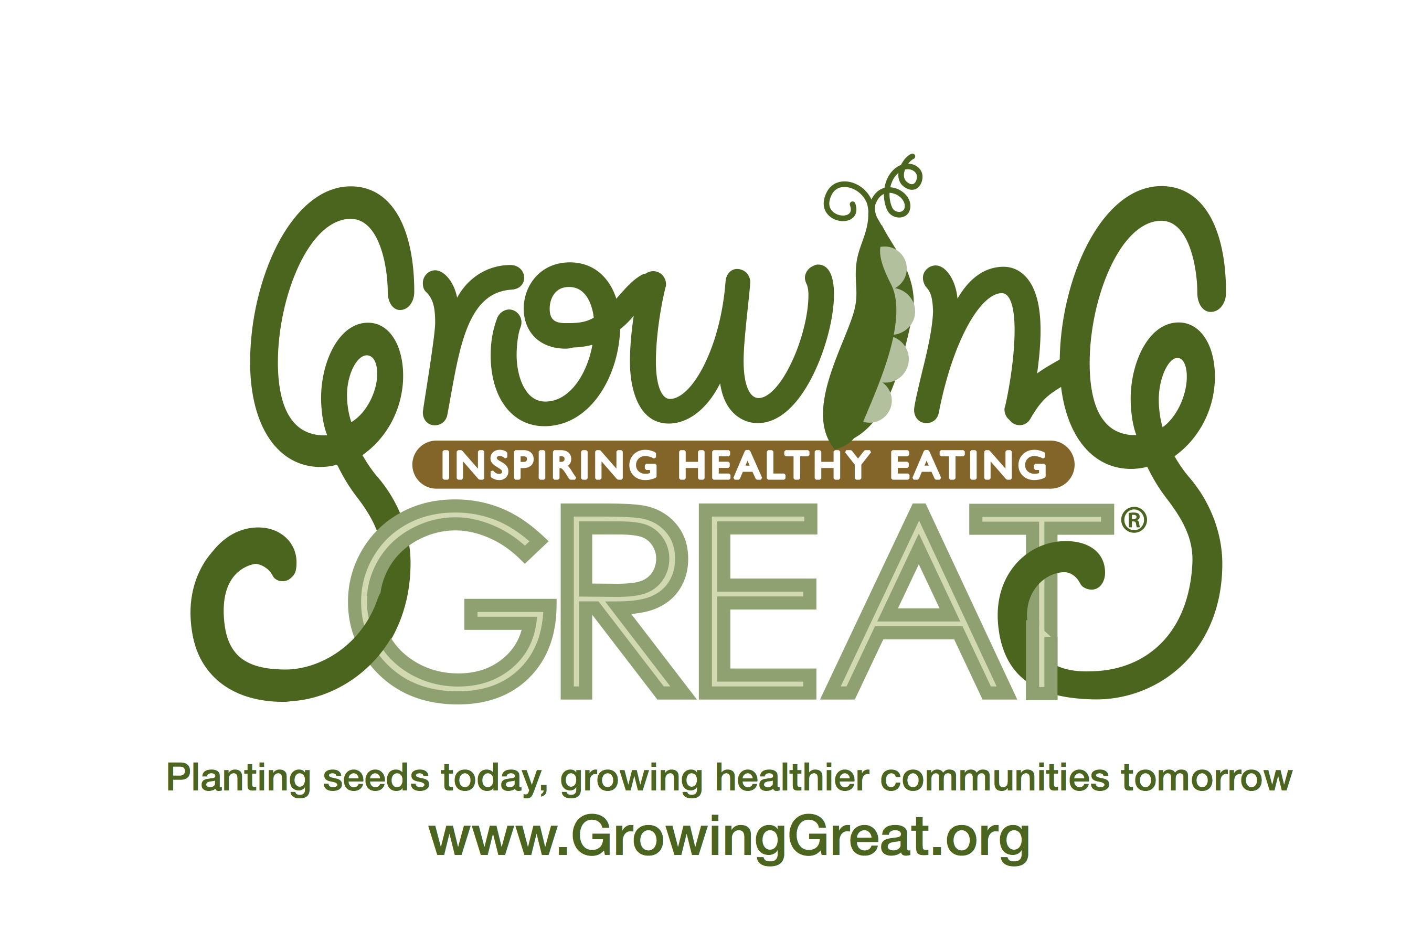

Dear Teacher:

GrowingGreat Pilot K-2nd Lesson #1—Decorate Your Plate

Today’s lesson is “Decorate Your Plate.” Your GrowingGreat Docent will lead the students through an interactive lesson designed to teach them that humans need food to live and grow and that there are five major food groups. A GrowingGreat “Grill Me About” handout for parents is available to be sent home via email or backpack. Please contact your GrowingGreat Docent for an electronic document.

Your Teacher Packet includes:

- An outline of the lesson

Suggested books to compliment the “Decorate Your Plate” lesson:

The Very Hungry Caterpillar by Eric Carle
I Will Not Ever Never Eat a Tomato by Lauren Child
Good Enough to Eat, a Kid’s Guide to Food and Nutrition by Lizzy Rockwell

We hope you and your students enjoy the lesson!

Sincerely,

GrowingGreat

LESSON OUTLINE
K-2 Pilot Lesson # 1: Decorate Your Plate

Objective: Students learn that humans need food to live and grow and that there are 5 major food groups.

Main Concepts:
  - Humans eat food to live and grow.
  - We want to strive for a balanced diet.
  - There are five food groups: fruits, vegetables, grains, dairy, and protein.
  - We should consume a fruit and/or vegetable at every meal.
  - Fill your plate with colorful fruit and vegetables to ensure you are eating a healthy variety.

Lesson Outline: (approximately 35 minutes)
- Read Book and Discuss (10 minutes)
- Read a book about food (Recommended: Monsters Don’t Eat Broccoli)
- Introduce food groups.

- Activity 1: Food group sorting activity (5 minutes)

- Activity 2: What’s Missing from My Plate? (5 minutes)
- Activity 3: What’s for Dinner? (10 minutes)

- Review/Conclusion (5 minutes)

Note: GrowingGreat curriculum aligns with Common Core Standards and Next Generation Science Standards. Please refer to the lesson script for standards.

