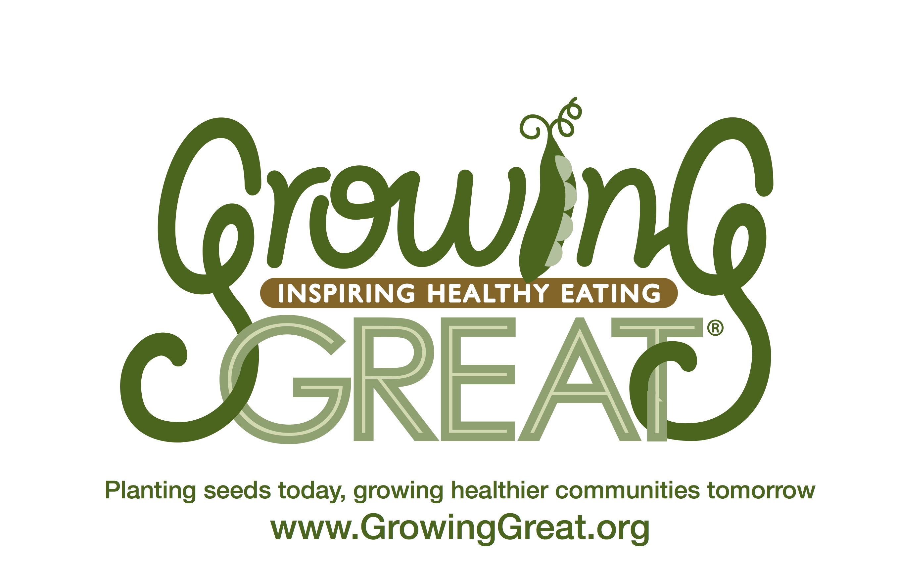
Supply Checklist
K-2 Pilot Lesson #1
Decorate Your Plate

Supplies provided by GrowingGreat Pilot Program:

Book for Lesson

- Monsters Don’t Eat Broccoli by Barbara Jean Hicks

Printed Images of Food Groups

- Printed images of each food group (5 total)

Activity #1: Food Group Sorting Activity

- Labeled brown bags
- Plastic toy food (1 item per student)

Activity #2: What’s Missing from My Plate?

- “What’s Missing from My Plate” printed images

Activity #3: What’s For Dinner?

- “What’s For Dinner” coloring worksheets

Supplies needed from classroom:

Activity #3: What’s For Dinner?
- Scissors
- Crayons/colored pencils
- Glue
- Food sample (optional)

