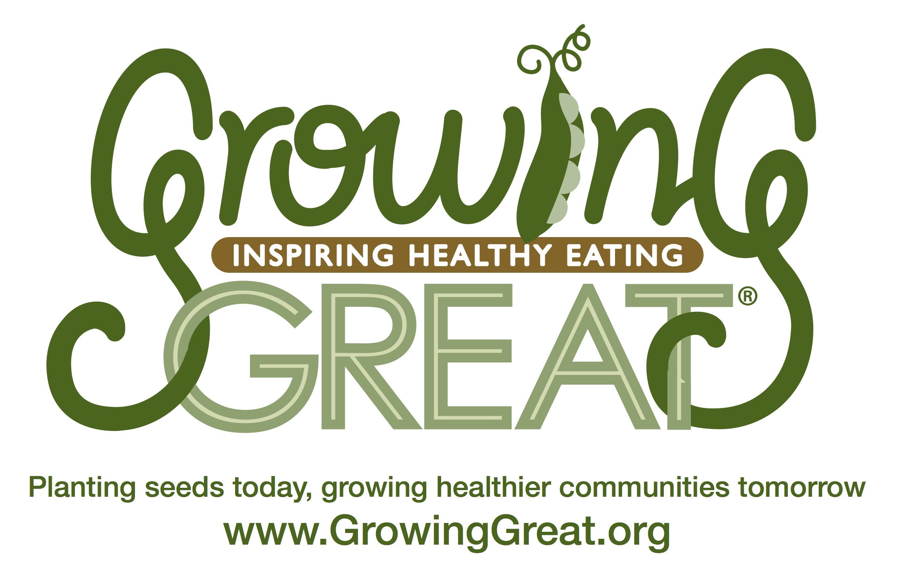
Grill Me About…
Decorate Your Plate
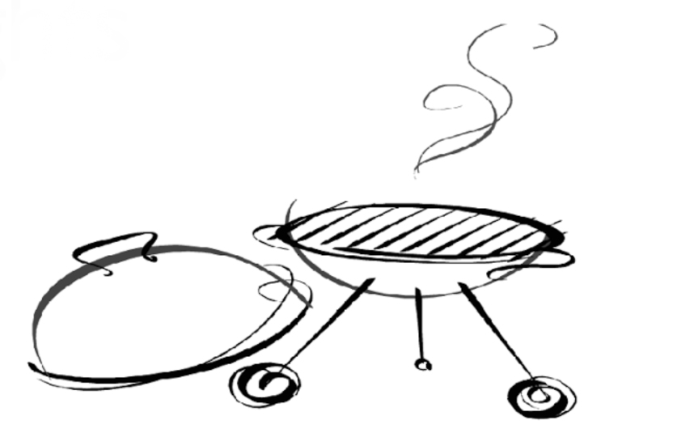
Ask me what I learned about in my “Decorate Your Plate” GrowingGreat classroom nutrition lesson:

- True or false: There are 3 food groups. (Bonus: What are the food groups?)

- True or false: Half of your plate at every meal should be made up of fruits and vegetables.
Super Green Smoothie
Serves 2

½ c. Milk (cow, almond, rice, soy or coconut milk)
2 c. Spinach
1 ½ c. Chopped pineapple (raw or frozen)
1 Ripe banana (raw or frozen)
½ c. water (add more if desired)
Blender

Directions:
Combine all ingredients and blend until smooth. Add ice if using fresh fruit.

- True or false: To make sure you are eating a variety of foods, everything on your plate should be one color.
…………………………………………………
Answers:
- False. There are 5 food groups – fruit, vegetables, grain, protein, and dairy or dairy substitutes.

- True. Fruits and vegetables are nutrient-dense and should be eaten at every meal.

- False. A plate filled with colorful foods means you are getting a healthy variety of foods.
Hands-On Science Corner: Play With Your Food
Next time you are at the grocery store with your children, talk about shapes, colors, and the names of fruits and vegetables. When you get home, take a moment to play with your food!
- Spread out 3 or 4 fruits or vegetables and ask questions. Which ones are the same colors? What grows in the ground? What grows on trees? Can you find the seeds?
- Ask your children to close their eyes. Hand them a food. Ask: What does it smell like? How does it feel? Can you guess what it is without peeking?

Visit the Resources section at www.GrowingGreat.org for more hands-on science activities.
K-2 Classroom Nutrition
Pilot Program: Lesson #1
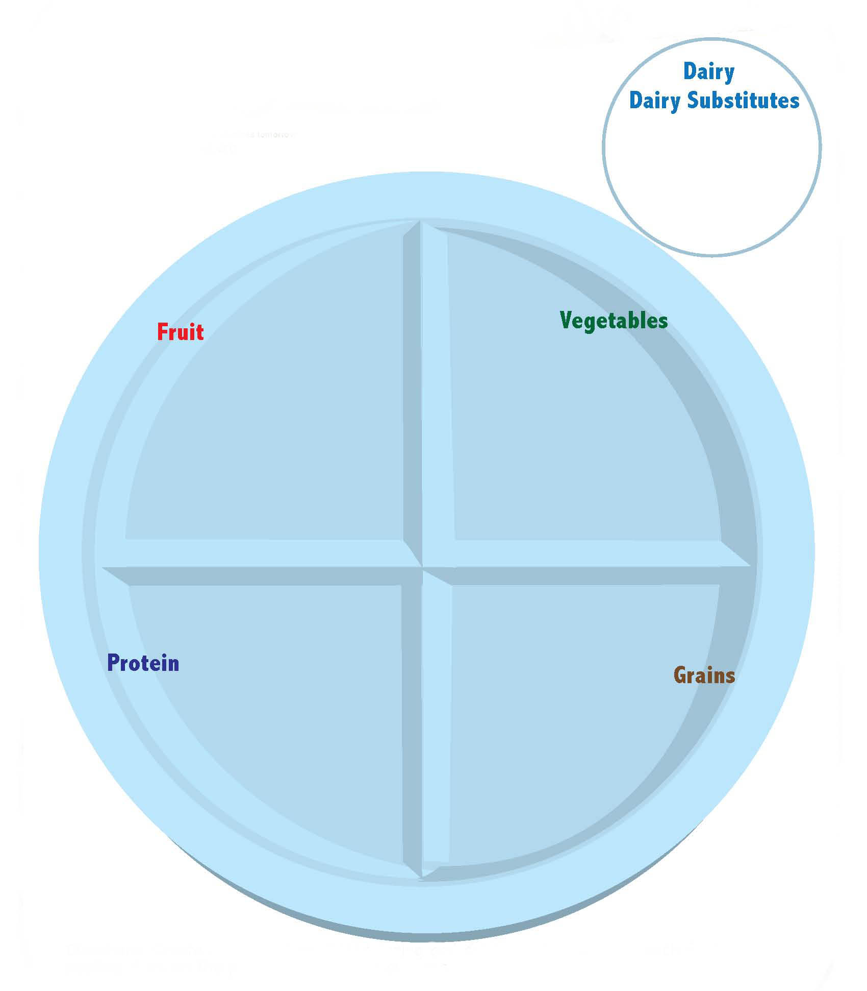
Decorate Your Plate

Eating a balanced diet means including foods from every food group – fruit, vegetables, grains, protein, and dairy or dairy substitutes. Fruit and vegetables are extra nutrient-rich foods that should make up half of your plate at every meal. The other half of your plate should be split between grains and protein. To ensure that you and your family are eating a wide variety of fruits and vegetables, decorate your plate with the colors of the rainbow at every meal. Here are some suggestions on how to choose high-quality options from each food group:

Fruit: Whole fruits are higher-quality options than juice because they contain more fiber.
Vegetables: Eat leafy greens at least once a day. Try new veggies and/or new preparation methods often to keep it interesting. Children’s taste buds change rapidly, so they might like something they didn’t like last week!
GrowingGreat’s Philosophy

GrowingGreat’s mission is to empower every child to grow up healthy through science-based garden and nutrition education.

GrowingGreat advocates:
- eating a wide variety of colorful, whole foods that are close to their original source
- choosing higher-quality, beneficial foods more often
- appreciating the impact food has on our overall well-being so that we can think, feel, and perform at our best all day long

Grains: Make most of your grains whole. Read ingredient labels and look for “whole” grains as the first ingredient. High-quality grain products are high in fiber and low in added sugar.
Protein: Lean meats like chicken, turkey, fish and plant proteins are high-quality options. Eat two servings of fish per week for optimal brain health. Incorporate plant protein sources such as beans, nuts, and seeds regularly for heart health.
Dairy/Dairy Substitutes: Dairy foods are good sources of calcium and vitamin D, but beware of added sugars, especially in yogurt and flavored milks. If you or your family does not eat dairy products, you can still get calcium from foods like almonds, broccoli, edamame (soy beans), and soymilk.

